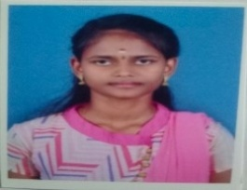

**SUGANYA S,**

Email:suganyasubramaniyan2021@gmail.com

Mobile: 8637610468

**CAREER OBJECTIVE:**

To work in a challenging and dynamic environment where, seamless integration of creativity and technology could be experienced with scope for professional advancement.

**PERSONAL STRENGTH:**

* Can aptly function as a team member in the organization.
* Sincere,efficient,timekeeper,ambitious ,and hard working.
* Adapting quickly to any environments and innovative roles.

**EDUCATIONAL QUALIFICATION:**

|  |  |  |  |
| --- | --- | --- | --- |
| **Qualification** | **Board\ Institution** | **Year** | **Percentage** |
| B.sc (CS) | Bharathiar University\  Govt Arts and Science College(Co-Education )-Avinashi | 2023-2026 | - |
| HSLC  (maths with computer science) | STATE BOARD\Govt Higher Secondary School-TIRUPPUR | 2020-2021 | 84% |
| SSLC | STATE BOARD\Govt High School-S.PERIYAPALAYAM | 2018-2019 | 88% |

**CERTIFICATES:**

* OOP using Python course completed in INFOSYS.
* Basic of Python course completed in INFOSYS.
* 3hours Workshop in Cyber Security completed in NoviTech.

**PERSONAL PROFILE:**

Name : Suganya

Father’s Name : Subramaiyan k

Mother’s Name : Gomathi s

Date of Birth : 01\01\2004

Gender : Female

Mother Tongue : Tamil

Language Known : English , Tamil.

Location : Tiruppur,Tamilnadu.

**DECLARATION:** I solemnly declare that the above mentioned details are true to the best of my knowledge. I am also confident of my ability to work.

